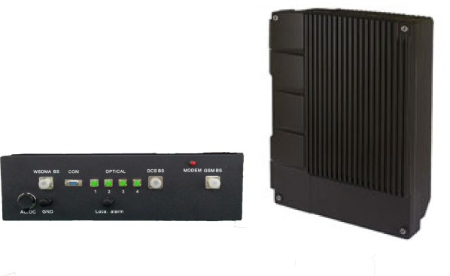

High Power Tri-Band
900-1800-2100MHz
Fiber Optic DAS System
Model No: FOR-91821-40W55
Features:
- Advanced Tri Band 900, 1800 & 2100MHz
- Supports Multi-band, Multi-operator and Multi-technologies GSM/WCDMA/LTE
- Connected direct to BTS or RF antenna
- Comply with ETSI, 3GPP & LTE standards
- 40dBm Downlink power per band (Optional: RF output 15- 40dBm), designed for in building or outdoor deployments
- Easy field installation and maintenance, reduces rollout and operational costs
- Advance monitoring systems with the possibility to send alarms via fiber cable from master to slave or via GSM modem
- 4 Remote units per master unit, designed to connect to POI (Point of Interconnection,) to support multi operator deployments.
- Compact Size in IP65 enclosure (Aluminum-alloy)
Introduction
The EMTS Telecom Services Ltd. Multi-band, Multi -Operator Fiber Optic Repeater system is the perfect solution to extend and improve the in building coverage area of 900/1800/2100MHz cellular systems in the campus area, tunnels, hospitals, shoppin malls and outdoor sites. The Fiber Optic Repeating system consists of Master and Remote (slave units ) with up to four slaves at one master unit. The Master unit is designed to be connected to a POI (point of interconnection) to support multi operator deployments, while the Slave module provides coverage in the service area and connected to the master unit via dark fiber. Fiber Optic Repeaters amplify in directions, uplink and downlink a continuous bandwidth, factory tuned. Its rugged construction and easy field maintenance, reduce operational costs and ensures a high MTBF. The EMTS Fiber Optic Repeating system is a cost-effective and practical solution for extending signal coverage in subways, tunnels and Indoor or outdoor distribution systems.

Technical Specifications
 |  | GSM/WCDMA/LTE |  |  | WCDMA/LTE
 |  | Downlink |  | Uplink | Downlink | Uplink
Frequency Range |  | 935-960MHz  1805-1880MHz |  | 890-915MHz  1710-1785MHz | 2110-2170MHz | 1920-1980MHz
Output Power |  | 40±2.0Bm |  | -10±2.0dBm | 40±2.0Bm | -10±2.0dBm
Max Gain |  | 55±3dB |  |  | 55±3dB
Gain Modulation Range |  | 30dB |  |  | 30dB
Gain Modulation Step |  | 1dB |  |  | 1dB
Gain Modulation Error |  | for gain 0-20dB,Error≤1dB;  for gain 21-30dB Error≤1.5dB |  |  | for gain 0-20dB,Error≤1dB;  for gain 21-30dB Error≤1.5dB
Noise Factor |  | / |  | ≤5dB | / | ≤5dB
Max NO Damage Input Power |  | 10dBm |  | -10dBm | 10dBm | -10dBm
Automatic Level Control (ALC) |  | Output power variation < 2dB or be off when adding 10dB at max output power. |  |  | Output power variation < 2dB or be off when adding 10dB at max output power.
Pass Band Ripple |  | ≤3dB |  |  | ≤2dB/3.84 MHz
VSWR |  | ≤1.5 |  |  | ≤1.5
Time Delay |  | ≤5.0μs |  |  | ≤5.0μs
IMD | In-Band | ≤-40dBc |  |  | /
IMD | Out-Band | 9kHz~1GHz: ≤-36dBm/30kHz |  |  | /
IMD | Out-Band | 1GHz~12.75GHz: ≤-30dBm/30kHz |  |  | /
ACLR(PAR=8dB) |  | / |  |  | ≤-45dBc@5MHz  ≤-50dBc@10MHz
Spurious Emissions |  | In-Band | ≤-36dBm/3kHz or ≤-60dBc/3kHz |  | Meet 3GPP
 |  | Out-Band | 9kHz～1GHz：≤-36dBm
 |  | Out-Band | 1GHz～12.75GHz：≤-30dBm
Frequency Stability |  | ≤0.05ppm |  |  | ≤0.01ppm
PCDE |  | / |  |  | ≤-35dB
Evm(RMS) |  | / |  |  | 12.5%
RF Connection Mode |  | N/F,50Ω
Type of Fiber Optical Cable |  | Single Mode
Fiber Optical Interface |  | FC/PC
Fiber Optical Loss |  | Max 8dBo
Remote Monitoring & Control |  | GSM MODEM

Power Supply Mode | Master Unit : DC-48VDC  Remote Unit : AC 110-220V
Power Consumption | Master Unit : ≤40W  Remote Unit : ≤350W
Optical Wavelength | 1310nm/1550nm
Number of Remote Units | 4 Remote Units per 1 Master Unit
Operation Temperature | -25℃ to +55℃
Casing class | Master Unit Unit:IP40  Remote Unit Unit:IP65
Machine Weight | Master Unit: ≤15kg  Remote Unit: ≤35kg
Dimension | Master Unit:483mm×133mm×400mm （W*H*L）  Remote Unit:490mm×410mm×187mm （W*H*L）
MTBF | ≥100000h

